**Custom Wheel Buying Guide For Cars: in 2021**

For a safe and smooth experience with your vehicle, you need to put on the best accessories with them. Such as you need to add the best transmission system for better acceleration, the best braking system for ultimate safety on road, high-quality tires, and rims for better grip. It is a major part of your car to choose the right tires and rims that fit well with your car. You may have fitted a high-class engine and transmission system in your vehicle but they won't be counted that much if you use a local tire and rim into your car.

Image Courtesy: **Top Speed**

Car accessories have now become very easy to find out and you may even order them online by just a few clicks on your device. While buying something, you need to perfectly know everything about that product. Likewise, there are a few things you need to keep in mind before buying tires for your car.

**Ride Quality**

We can analyze ride quality in two parts. 40-50 series tires that belong to low profile tires, and 55-60 series that belong to high profile tires. Low-profile tires are good with handling but not very comfortable. These tires provide a stiff or tough riding experience. High sensitivity to tire and rim damage as these tires have a smaller air coil to absorb severe path-holes impacts. Wheels are more likely to harm roads with low-profile pneumatic tires.

High-profile tires have a longer space between the road and the car as they have a shorter space between the road and the car, with low-profile tires. If you are an automotive driver, that signifies a lot for you. Bigger tires and wheels mean that brakes need to be bigger and better. For comfort riding, a high-profile tire is best. In general terms, low-profile pneumatic tires improve braking and cornering performance on dry roads. Usually, higher-profile pipes are quieter and can be more coated. Since there is a smaller sidewall in a low-profile tire, the sidewall is of course less flexible. Low-profile tires tend to cost more than bigger sidewalls tires.

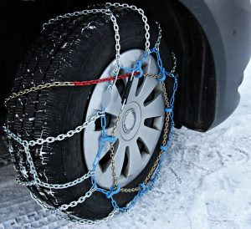

Image Courtesy: **Scott Clark Nissan**

**Adjustment With Weather Condition**

This is one of the vital considerations for the people living in desert areas or snowy areas. Sand, like sandpaper, is quite abrasive - you know. Off-path surfaces are typically at least as abrasive as paddling. A good new snowfall might make this easier so long as it does not create spinning wheels. A larger diameter tire in the sand is useful. A bigger pneumatic tire has a flatter surface contact and might therefore aid to make the sand look more solid.

If the weather is warm and snowy, tires and a number of snow chains can be appropriate throughout the whole season for events. Without chains, however, all-season pneumatic tires will assist you to keep grip and control in harsh snowy, icy, or slush conditions as a winter pneumatic tire. Under snowy circumstances, snow tires provide higher traction. Snow tires are overpowered under snowy, icy conditions throughout the season. They will provide you more traction, improved rotational stability, and greater power stopping.

**Ratings Over Speed**

Speed ratings are shown by alphabetical lettering that indicates a certain speed in miles per hour(mph) for which the tire is tested and the quality rating is shown. The symbols below are:

Q= 99 mph S= 112 mph T= 118 mph U= 124 mph H= 130 mph V= up to 149 mph Z= 149 mph and above W= 168 mph Y= 186 mph

High-speed tires are compounded by soft rubber and will have a smaller lifespan than slow-speed tires.

**Expected Life-Cycle**

A tire is provided with a guarantee offered to its consumers by the producing business. By its guarantee, which might be around 40 000 miles, you may evaluate the life of the tire. The other option is to examine UTQG ratings that every tire should have under the US Department of Transport guidelines. UTQG (Uniform Tire Quality Grading). Of course, the real performance may vary according to the conditions in which they are driven, but these values might provide information for comparative purposes.

There is universal agreement that most tires, if not changed, should be evaluated after around six years and completely changed off after ten years, regardless of how tired. While governmental safety instructions are not available if the tire is too old for safety, many automobile manufacturers advocate substitutions for the tire at a time of six years from the manufacturing date. In tragic collisions, old tires were the culprit.

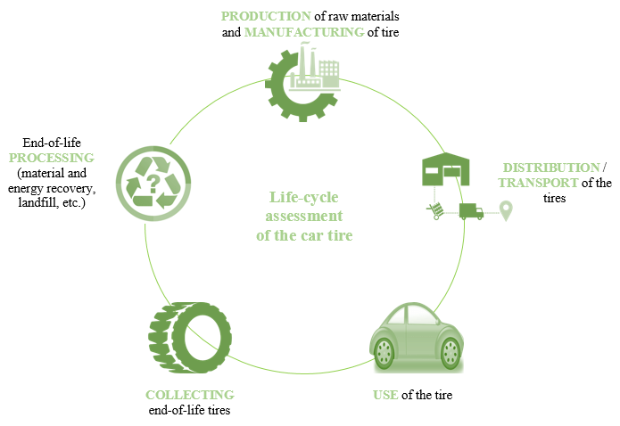

Image Courtesy: **ResearchGate**

**Tire Noise**

Uneven wear is a major cause of tire sounds because of the lack of uniform contact of the road with uneven tires. Unbalanced tread depths lead to pneumatic driving to produce loud sounds. In general, you hear noises from one tire produced by uneven wear. Problems with alignment may also generate pneumatic sounds. You might ask the seller whether there are additional sounds on the tires. Certain tread designs produce noise. It also relies on velocity. This is important while driving at high speeds on a road or on calmer routes.

**Tread Wear Info**

These two facts assist you to estimate the number of miles you may expect from a set of tires: the rating for tread wear and the tire mileage guarantee. The rating of the tread wear is printed on the sidewall below the phrase "tread wear." The greater the number, the longer the tire lasts. However, the tests used to measure the treadwear are not accurate, and this value thus has a great fluctuation.

A better technique to measure the lifespan of the possible pneumatic tires and compare the predicted life span of the different tires is to examine the tread-life guarantee of the manufacturers. In addition to the manufacturer's quality/defect guarantees, many but not all tires provide a tread-life guarantee. This information is available online or in the marketing brochures of the tire manufacturer. The basic rule of the business is that around three-quarters of the riders will see their tires endure as long as the kilometers are covered by a lifetime guarantee. Usually, you may obtain a credit for the percentage of miles you were short, which you can subsequently utilize to the purchase of a new tire if your tires are wearing out before your promised miles bogey.